To obtain the spectrogram plots you should run the matlab file “spectrogram_matlab_plots.mlx” using these steps. Make sure you are in the directory “spectrogram generation”.

1. Add some wav files to the folder “datafiles”

2. Set pyenv by inserting the path to your python executable (the output of “which python” in your command prompt) between the “” in: pyenv("Version”, “”).

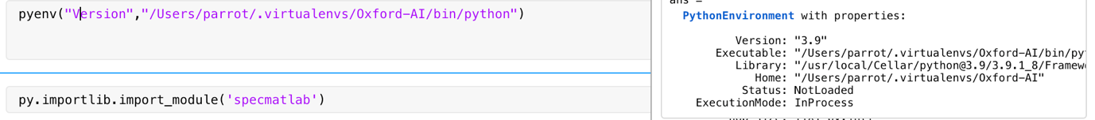

3. Run “pip install -r requirements.txt”

4. Run the other lines.

Notes:

1. “spec_matlab plots” is folder where the png spectrograms are outputted
2. The training text file “nn_ele_hb_00-24hr_TrainingSet_v2.txt” should be in the directory
3. “specmatlab.py” is the python script that extracts the audio files which we then import into matlab for processing